

EFFICIENT SUDOKU GENERATION AND SOLVING USING RECURSIVE BACKTRACKING

A CAPSTONE PROJECT REPORT
A Capstone Project Report submitted in partial fulfilment of the requirements for the Course of

CSA0603 & DESIGN AND ANALYSIS OF ALGORITHMS
to the award of the degree of

BACHELOR OF TECHNOLOGY
IN
INFORMATION TECHNOLOGY
Submitted by
Aksharaa.B (192311278)
Akshaya A (192421222)
Jeslet Jessica (192524135)
Gayathri N P (192421362)
Under the Supervision of
Dr. Solainayagi
SIMATS ENGINEERING
Saveetha Institute of Medical and Technical Sciences Chennai-602105

SEPTEMBER 2026

SIMATS ENGINEERING
Saveetha Institute of Medical and Technical Sciences Chennai-602105

BONAFIDE CERTIFICATE

This is to certify that the Capstone Project entitled “EFFICIENT SUDOKU GENERATION AND SOLVING USING RECURSIVE BACKTRACKING” has been carried out by Gayathri N P(192421362) under the supervision of Dr. Solainayagi and is submitted in partial fulfilment of the requirements for the current semester of the program Computer Science And Engineering at Saveetha Institute of Medical and Technical Sciences, Chennai.

COURSE COORDINATOR COURSE FACULTY
Dr.G.Charlyn Pushpa Latha Dr. Solainayagi
Professor Professor
Computer Science And Engineering Computer Science And Engineering
SIMATS Engineering, SIMATS Engineering,
SIMATS, Chennai – 602105. SIMATS, Chennai – 602105.
SIMATS ENGINEERING
Saveetha Institute of Medical and Technical Sciences Chennai-602105

DECLARATION

I, Gayathri N P (192421362) of the Information Technology, SIMATS Engineering, Saveetha Institute of Medical and Technical Sciences, Chennai, hereby declare that the Capstone Project Work entitled “EFFICIENT SUDOKU GENERATION AND SOLVING USING RECURSIVE BACKTRACKING” is the result of our own bonafide efforts. To the best of our knowledge, the work presented herein is original, accurate, and has been carried out in accordance with the principles of engineering ethics and academic integrity. All sources, references, data, and other materials used in the project have been appropriately acknowledged. We further declare that the data, results, analysis, and findings presented in this report have not been fabricated, falsified, or manipulated. Any external tools, software, datasets, computational resources, or AI-assisted tools used during the project have been appropriately disclosed. We confirm that all applicable ethical, academic, institutional, and professional requirements have been duly followed throughout the planning, execution, analysis, and documentation of the project.

Place:
Date:
Signature of the Students with Names
Gayathri N P

INDIVIDUAL CONTRIBUTION STATEMENT
The following allocation is a proposed project-role distribution for documentation. The team should revise the percentages if the actual contribution differs.
Student Name / Register No. | Specific Responsibilities | Design & Development | Testing & Analysis | Report Contribution | Approx. Contribution (%)
Aksharaa.B / 192311278 | Sudoku generation and system development | Puzzle generation and algorithm implementation | Puzzle testing | Project documentation | 25%
Akshaya A / 192421222 | Sudoku solving module | Recursive Backtracking solver | Solver testing and analysis | Report preparation | 25%
Jeslet Jessica / 192524135 | Validation and performance analysis | Validation module | Performance evaluation | Documentation | 25%
Gayathri N P / 192421362 | User interface and visualization | GUI development | Interface testing | Presentation and report | 25%
Total |  |  |  |  | 100%

ABSTRACT

Sudoku is a constraint-oriented puzzle that can be used to illustrate several important algorithmic ideas, including recursive search, constraint verification and backtracking. Although the puzzle is simple to describe, a computer must examine a large set of possible assignments when many cells are unknown. This makes Sudoku a useful case study for understanding how an algorithm can explore alternatives and recover from unsuccessful choices.

This project develops an interactive Sudoku application that combines puzzle generation, automated solving, validation and graphical presentation. Recursive Backtracking is used as the main solving strategy. The solver locates an unfilled position, evaluates candidate values, verifies the row, column and corresponding 3×3 region, and proceeds recursively when a candidate is acceptable. When a later decision makes completion impossible, the algorithm returns to an earlier state and tries another candidate.

The implementation is organized into four cooperating components: puzzle generation, recursive solving, validation/performance analysis, and graphical interaction. Python is used for the application logic and Tkinter is used for the desktop interface. The system supports different puzzle difficulty levels and provides operations for generating, solving, validating and clearing a board.

The project demonstrates that a straightforward backtracking strategy can provide a dependable solution for standard 9×9 Sudoku while remaining easy to trace and explain. The work also identifies the limitations of plain backtracking and proposes improvements such as Minimum Remaining Values, uniqueness checking, richer difficulty estimation and step-by-step visualization.

Keywords: Sudoku, recursive search, backtracking, constraint checking, puzzle generation, Tkinter, algorithm analysis.

TABLE OF CONTENTS
Sl. No. | Title | Page No.
i | CERTIFICATE FROM THE SUPERVISOR | ii
ii | DECLARATION BY THE CANDIDATE | iii
iii | INDIVIDUAL CONTRIBUTION STATEMENT | iv
iv | ABSTRACT | v
v | LIST OF FIGURES | vi
vi | LIST OF TABLES | vii
vii | LIST OF ABBREVIATIONS / SYMBOLS | viii
1 | CHAPTER 1: INTRODUCTION AND ENGINEERING PROBLEM | 10
2 | CHAPTER 2: LITERATURE REVIEW AND EXISTING SOLUTIONS | 14
3 | CHAPTER 3: ENGINEERING DESIGN & TRADE-OFFS, SUSTAINABILITY, ETHICS, SAFETY, RISK & SECURITY | 17
4 | CHAPTER 4: IMPLEMENTATION, TESTING & RESULTS, PROJECT MANAGEMENT | 22
5 | CHAPTER 5: CONCLUSION, FUTURE WORK AND REFLECTION | 28
 | REFERENCES | 31
 | APPENDICES | 33

LIST OF FIGURES
Figure No. | Figure Name | Page No.
1.1 | Conceptual view of dust accumulation and visible module defects | 2
3.1 | Proposed computer-vision system architecture | 9
4.1 | Conceptual model output for localized dust and defect regions | 15
4.2 | Recommended evaluation metrics | 17
4.3 | Indicative project milestone timeline | 19

LIST OF TABLES
Table No. | Table Name | Page No.
2.1 | Comparison of existing PV inspection approaches | 5
3.1 | Stakeholder and user requirements | 8
3.2 | Functional and non-functional requirements | 8
3.3 | Constraints and applicable standards | 9
3.4 | Design specifications | 10
3.5 | Alternative solution evaluation matrix | 10
3.6 | Trade-off analysis | 11
3.7 | Sustainability, ethics, safety and security assessment | 12
3.8 | Project risk register | 12
4.1 | Software and computational resources | 14
4.2 | Test plan and verification criteria | 16
4.3 | Result-recording template | 17
4.4 | Objective achievement matrix | 18
4.5 | Roles and budget framework | 19

LIST OF ABBREVIATIONS / SYMBOLS
Symbol | Description | Unit
AI | Artificial Intelligence | —
CNN | Convolutional Neural Network | —
CV | Computer Vision | —
EL | Electroluminescence | —
FN | False Negative | count
FP | False Positive | count
F1 | F1-score | —
IoU | Intersection over Union | —
PV | Photovoltaic | —
RGB | Red–Green–Blue | —
ROI | Region of Interest | —
TP | True Positive | count
UAV | Unmanned Aerial Vehicle | —
mAP | mean Average Precision | —

CHAPTER 1
INTRODUCTION AND ENGINEERING PROBLEM
1.1 Background
Sudoku can be represented as a 9×9 constraint problem. Every row, every column and each 3×3 region must contain the values 1 through 9 without repetition. From a Design and Analysis of Algorithms perspective, this structure naturally leads to a search problem: the program must select values for empty locations while preserving all constraints.
A manual solver can reason about candidates directly, but a computer program needs an explicit procedure for deciding which value to try, how to detect an invalid choice and how to recover when a selected path cannot lead to a complete board. Recursive Backtracking provides this mechanism by treating each tentative placement as a decision in a search tree.
The developed application extends the solver into a small complete system. It creates puzzles, accepts or displays a board, searches for a solution, checks validity and presents the process through a desktop interface.
1.2 Need for the Project
- To automate the creation of standard 9×9 Sudoku puzzles.
- To replace repeated manual trial-and-error with a systematic search procedure.
- To verify row, column and 3×3-region constraints automatically.
- To demonstrate recursion and backtracking in a practical DAA problem.
- To provide a simple interface through which users can generate, solve and validate boards.
- To observe algorithm behaviour using execution-time and recursive-operation measurements.
1.3 Problem Statement
The project addresses the problem of building a software system that can construct playable 9×9 Sudoku boards and solve incomplete boards without violating Sudoku constraints. The system should detect invalid candidates early, reverse unsuccessful decisions and present the resulting board through an accessible graphical interface. The implementation should remain modular so that individual functions can be tested without depending entirely on the interface.
1.4 Aim
To design and implement an interactive Sudoku generation and solving application in Python, using Recursive Backtracking as the principal search method and integrating validation, performance observation and graphical interaction.
1.5 Objectives
- Develop a modular structure for puzzle creation, solving, validation and interaction.
- Generate valid 9×9 Sudoku configurations and produce puzzles at different difficulty levels.
- Implement a recursive solver that explores candidate values and reverses failed choices.
- Check row, column and 3×3-region constraints before accepting a value.
- Evaluate the solver using execution time and recursive-operation observations.
- Create a Tkinter interface for common user actions such as Generate, Solve, Validate and Clear.
- Test the integrated application using valid, invalid and solvable puzzle cases.
1.6 Scope
The present work is restricted to conventional 9×9 Sudoku and a desktop Python implementation. It covers puzzle generation, recursive solving, constraint validation, basic performance observation, difficulty selection and GUI interaction.
The current version does not include OCR-based board recognition, online multiplayer, cloud services, mobile deployment, large Sudoku variants or advanced heuristic solvers. These are treated as possible extensions rather than current implementation features.
1.7 Expected Engineering Outcome
The expected outcome is a functioning desktop prototype in which a user can obtain a Sudoku puzzle, invoke the solver, check board validity and reset the interface. At the algorithmic level, the system should illustrate how recursive exploration and controlled reversal can solve a constraint-based problem

CHAPTER 2
LITERATURE REVIEW AND EXISTING SOLUTIONS
2.1 Review Method
Relevant studies and existing approaches related to Sudoku solving, recursive backtracking, constraint-based search and alternative solving algorithms were reviewed.
The approaches are compared based on their solving strategy, computational requirements, advantages, limitations and suitability for the proposed Sudoku system.
2.2 Review of Existing Work
Sudoku solving has been studied using different algorithmic approaches. Recursive Backtracking is one of the commonly used techniques because it systematically explores possible assignments while reversing decisions that lead to invalid configurations.
Other approaches can use techniques such as constraint propagation, heuristic search and metaheuristic algorithms. These approaches may improve solving efficiency for particular puzzle configurations but can also introduce additional algorithmic complexity.
The proposed project selects Recursive Backtracking because it clearly demonstrates recursion, systematic search and backtracking while providing an understandable implementation suitable for the project objectives.
The PPT references studies comparing backtracking with approaches such as simulated annealing, alternating projection, constraint propagation and Dancing Links.

2.3 Comparative Analysis
Existing Approach | Advantages | Limitations | Relevance
Manual Solving | Simple for humans | Time-consuming for difficult puzzles | Low
Recursive Backtracking | Systematic and easy to implement | May require large search for difficult puzzles | Highly Relevant
Constraint Propagation | Reduces candidate space | More complex implementation | Relevant
Metaheuristic Methods | Can solve complex configurations | Computationally more complex | Provides comparison
Dancing Links | Efficient exact-cover approach | More complex implementation | Alternative

2.4 Research / Engineering Gap
Existing Sudoku-solving techniques provide different levels of efficiency and complexity. Advanced approaches may require more sophisticated data structures, heuristics or optimization techniques.
There is a need for a simple and understandable algorithmic approach that can demonstrate how a constraint-based puzzle can be solved systematically.
The proposed project addresses this requirement using Recursive Backtracking, combined with constraint checking and performance analysis.

2.5 Proposed Contribution
The proposed project develops an integrated Sudoku application with four modules:
- Module 1 – Puzzle Generation
- Module 2 – Sudoku Solver using Recursive Backtracking
- Module 3 – Puzzle Validation & Performance Analysis
- Module 4 – User Interface & Visualization
Module 2 forms the main solving component by exploring possible values recursively and backtracking whenever a conflict occurs. Module 3 evaluates the correctness and performance of the solution, while Module 4 provides an interactive visualization.

CHAPTER 3
ENGINEERING DESIGN & TRADE-OFFS, SUSTAINABILITY, ETHICS, SAFETY, RISK & SECURITY
3.1 Requirements
Stakeholder / User Requirements
Stakeholder | Requirement
User | Generate Sudoku puzzles easily
User | Select puzzle difficulty
User | Solve Sudoku automatically
User | Validate a Sudoku solution
User | View solving results
Student/Developer | Analyse algorithm performance

Functional & Non-Functional Requirements
Requirement | Type | Measurable Target
Generate puzzle | Functional | Valid Sudoku puzzle generated
Select difficulty | Functional | Easy/Medium/Hard available
Find empty cell | Functional | Empty cell identified
Check candidate | Functional | Row, column and sub-grid checked
Solve puzzle | Functional | Valid solution generated
Backtrack | Functional | Incorrect candidate removed
Validate solution | Functional | Sudoku rules verified
Performance | Non-Functional | Execution time and recursive calls measured
Usability | Non-Functional | Simple interactive interface

3.2 Constraints & Applicable Standards
Standard / Requirement | Requirement | Application
Sudoku Rules | No duplicate values in rows | Applied during solving
Sudoku Rules | No duplicate values in columns | Applied during solving
Sudoku Rules | No duplicate values in 3 × 3 sub-grids | Applied during solving
Algorithmic Constraint | Invalid candidates should not be placed | Constraint checking
Software Design | Modular implementation | Four project modules
Performance | Solver efficiency should be measurable | Execution time and recursive calls

3.3 Design Specifications
Parameter | Target / Requirement | Unit | Priority
Grid Size | 9 × 9 | Grid | High
Candidate Values | 1–9 | Number | High
Row Constraint | No duplicate values | — | High
Column Constraint | No duplicate values | — | High
Sub-grid Constraint | No duplicate values | — | High
Solver | Recursive Backtracking | Algorithm | High
Search Method | Depth-First Search | — | High
Performance | Execution time and recursive calls | Measures | Medium

3.3 Alternative Solutions & Evaluation
Alternative 1: Manual Solving
Manual solving depends on human reasoning and can become time-consuming for difficult puzzles.
Alternative 2: Recursive Backtracking
Recursive Backtracking systematically explores candidate values and reverses invalid choices. It is selected because it is suitable for demonstrating recursion and backtracking concepts.
Alternative 3: Advanced Heuristic Methods
Heuristics such as Minimum Remaining Values can reduce the search space, but they introduce additional implementation complexity and are considered as future enhancement.
Criterion | Manual | Recursive Backtracking | Advanced Heuristic
Performance | Low | High | High
Implementation Complexity | Low | Medium | High
Constraint Handling | Manual | Automatic | Automatic
DAA Demonstration | Medium | High | High
Selected | No | Yes | Future

3.4 Selected Design & Detailed Design
The Recursive Backtracking algorithm is selected as the core Sudoku-solving technique.
The solver receives an incomplete Sudoku grid and searches for an empty cell. It then attempts possible numbers from 1 to 9. A number is placed only when it satisfies the row, column and sub-grid constraints.
The algorithm recursively continues this process. If no valid candidate can be placed at a later stage, the algorithm backtracks to the previous decision and tries another candidate.

Key Engineering Process
Input Puzzle → Empty Cell → Candidate Number → Constraint Check → Place Number → Recursive Call → Conflict? → Backtrack → Continue → Solved Puzzle
3.4 Trade-off Analysis

Design Decision | Alternative | Benefit | Disadvantage | Final Decision
Recursive solving | Manual solving | Systematic search | May require many recursive calls | Recursive solving
Backtracking | Trial-and-error | Controlled reversal | Can increase search time | Backtracking
Constraint checking | Blind search | Prevents invalid paths | Requires validation at every step | Constraint checking
9 × 9 grid | Variable grid | Standard Sudoku format | Limited to standard Sudoku | 9 × 9
Tkinter GUI | Command-line interface | Better visualization | Additional implementation | Tkinter

3.5 Sustainability, Ethics, Safety, Risk & Security
Sustainability
The project is primarily software-based and requires no specialized physical resources. Efficient search and constraint checking help reduce unnecessary computation.
Ethics
The system should produce correct and reproducible results. The project documentation acknowledges the algorithms and references used in the development.
Health & Safety
The system does not directly control physical hardware. Its operation is limited to software-based puzzle generation and solving.
Security
The application performs controlled processing of Sudoku grid data. No sensitive user information is required for the basic system.
Risk Register

Risk | Likelihood | Severity | Risk Level | Mitigation | Residual Risk
Excessive recursive calls | Medium | Medium | Medium | Constraint checking | Low
Invalid puzzle generation | Medium | High | High | Puzzle validation | Medium
Slow solving for difficult puzzle | Medium | Medium | Medium | Performance analysis | Low
GUI input error | Low | Medium | Low | Input validation | Low
Incorrect solution | Low | High | Medium | Solution validation | Low

CHAPTER 4
IMPLEMENTATION, TESTING & RESULTS, PROJECT MANAGEMENT
4.1 Development Approach
Development followed a modular sequence. Puzzle generation, solving, validation/performance measurement and the user interface were treated as separate responsibilities before being connected into the final application. This approach reduced the risk of mixing interface errors with algorithm errors and made individual functions easier to test.
Component | Role
Puzzle Generation | Builds a valid Sudoku structure and creates a playable puzzle.
Recursive Solver | Searches candidate values and backtracks after failed choices.
Validation / Performance | Checks correctness and records solver observations.
User Interface | Provides board display, controls and user interaction.

4.2 Software and Tools
Tool / Technology | Purpose
Python 3.x | Core implementation and algorithm logic
Tkinter | Desktop graphical interface
VS Code | Editing, execution and debugging
Python standard libraries | Randomization, timing and application support
Windows PC | Development and execution environment

4.3 Implementation Logic
The generation stage prepares a valid Sudoku arrangement and removes selected cells to create a puzzle. The solver then searches for the first available empty position. Candidate numbers are considered one by one. A candidate is accepted only if it does not duplicate a value in the relevant row, column or 3×3 region. After a placement, the function calls itself for the next empty position.
When the recursive call cannot continue, the most recent candidate is cleared and another candidate is attempted. This reversal is the key backtracking operation. The process ends successfully when there are no empty positions left.
The validation stage independently examines the completed board. The interface layer connects the algorithmic functions to user controls, allowing the same underlying functions to be exercised without changing the search logic.
4.4 Test Plan and Verification
Test | Method | Expected result
Generation | Create puzzles at each difficulty | Valid 9×9 puzzle is produced
Empty-cell detection | Provide an incomplete board | An empty position is identified
Candidate checking | Try legal and illegal values | Illegal choices are rejected
Row validation | Introduce a duplicate in a row | Board is marked invalid
Column validation | Introduce a duplicate in a column | Board is marked invalid
Region validation | Introduce a duplicate in a 3×3 region | Board is marked invalid
Backtracking | Use a board requiring reversal | Failed choice is undone and search continues
Solving | Provide a solvable board | Complete valid solution is returned
GUI | Press Generate, Solve, Validate and Clear | Each control performs its intended action

4.5 Verification Summary
Specification | Observed implementation | Status
9×9 grid | 9×9 Sudoku board | Pass
Values 1–9 | Numeric candidate range | Pass
Row constraints | Implemented | Pass
Column constraints | Implemented | Pass
3×3 constraints | Implemented | Pass
Recursive solver | Implemented | Pass
Difficulty selection | Implemented | Pass
GUI controls | Implemented | Pass

4.6 Results and Engineering Interpretation
The integrated application demonstrates the intended Sudoku workflow: a board can be generated, examined, solved and validated through the same interface. The solving stage follows the expected recursive pattern and returns from unsuccessful branches rather than continuing with an invalid partial board.
The computational effort is not identical for every puzzle. Boards with fewer useful candidate choices may require more exploration, while boards whose constraints narrow the search quickly can be completed with fewer recursive operations. Consequently, execution time and recursive-call count are useful complementary measures when comparing difficulty levels.
Exact numerical performance values should be taken from the actual run of the application. The supplied team reports identify these metrics but do not provide a reliable set of measured numbers, so this revised report intentionally does not invent them.
4.7 Comparison with Existing Solutions
Feature | Manual approach | Developed application
Puzzle generation | Human-created | Automated
Candidate checking | Human reasoning | Programmatic validation
Solving | Manual reasoning | Recursive search
Backtracking | Manual reconsideration | Automatic reversal
Validation | Manual inspection | Automated checks
Performance observation | Difficult to quantify | Execution/recursive measures available
Visualization | Physical or static board | Interactive GUI

4.8 Strengths and Limitations
Strengths
- Clear demonstration of recursion and backtracking.
- Automatic constraint checking.
- Integrated generation, solving and validation.
- Difficulty selection and interactive controls.
- Modular structure suitable for testing and extension.
- No specialized hardware requirement.
Limitations
- Restricted to standard 9×9 Sudoku.
- Plain backtracking can become expensive for difficult boards.
- Generation does not automatically establish uniqueness unless an additional uniqueness test is used.
- No OCR or image-based puzzle entry.
- No web/mobile deployment in the present version.
- Advanced heuristics are not part of the current solver.
4.9 Project Planning, Roles and Budget
Activity | Status
Problem definition | Completed
Literature review | Completed
Architecture and module design | Completed
Puzzle generation | Completed
Recursive solver | Completed
Validation and performance work | Completed
GUI implementation | Completed
Integration testing | Completed
Documentation and presentation | Completed

Member | Project role
Aksharaa B | Puzzle generation
Akshaya A | Recursive Backtracking solver
Jeslet Jessica | Validation and performance analysis
Gayathri N P | User interface, visualization and integration support

Resource | Estimated / actual cost
Existing laptop / PC | ₹0 / ₹0
Python / Tkinter / standard libraries | ₹0 / ₹0
VS Code | ₹0 / ₹0
Internet / research resources | ₹0 / ₹0
Printing / documentation | ₹200 / ₹200

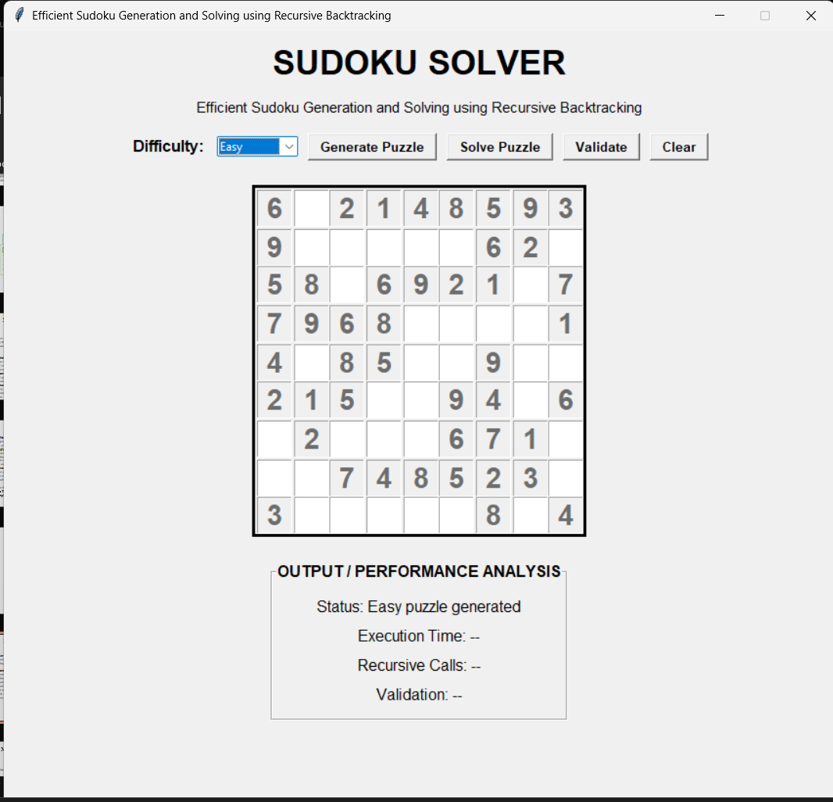

CHAPTER 5
CONCLUSION, FUTURE WORK AND REFLECTION
5.1 Conclusion
The project produced a complete desktop Sudoku prototype that connects puzzle generation, recursive solving, validation and graphical interaction. The core solver uses Recursive Backtracking to explore possible values while respecting row, column and 3×3-region constraints. When a selected path fails, the program returns to an earlier decision and continues the search with an alternative.
Beyond solving the puzzle, the project provides a practical demonstration of DAA concepts. The modular design makes it possible to test generation, solving, validation and interface behaviour separately and then verify the integrated workflow. The work also shows why algorithm selection involves trade-offs: a simple algorithm can be easier to understand and maintain even when a more sophisticated approach may reduce search effort.
5.2 Future Enhancements
- Add a uniqueness-checking stage so generated puzzles can be confirmed to have a single solution.
- Introduce Minimum Remaining Values and related heuristics to reduce unnecessary exploration.
- Estimate difficulty using actual solving effort rather than only the number of removed clues.
- Animate the search so users can see placements and backtracking decisions.
- Provide optional hints without immediately revealing the complete solution.
- Support larger formats such as 16×16 Sudoku.
- Develop web or mobile versions.
- Compare plain backtracking with constraint propagation and Dancing Links.
- Store non-sensitive solving statistics such as time and number of search operations.
5.3 Professional Learning
The project strengthened understanding of recursive problem solving, state changes, constraint validation and algorithmic search. It also provided practical experience in Python modularization, debugging, GUI event handling, integration testing and technical documentation.
Working on the interface highlighted an important software-engineering principle: presentation logic should remain separate from the algorithmic core. This separation makes the application easier to modify because the solver can be improved without redesigning every GUI control.
5.4 Individual Reflection – Gayathri N P
My main contribution was the User Interface and Visualization module. I focused on making the Sudoku functions accessible through a simple Tkinter window and on connecting user actions to the corresponding generation, solving, validation and clearing operations. One of the main challenges was ensuring that interface events triggered the correct underlying function without changing the behaviour of the solving algorithm.
Through this work, I gained practical experience with Tkinter widgets, event-driven programming, function integration and interface testing. I also learned that a technically correct algorithm is not enough for an interactive application; the user must be able to understand the current board state and operate the available controls without confusion.
If I continue the project, I would improve the interface by adding a visual step-by-step solver, clearer feedback for invalid entries, optional hints and a more informative performance panel. These changes would make the algorithm easier to observe while keeping the existing solver structure intact.

REFERENCES
- E. C. Chi and K. Lange, “Techniques for Solving Sudoku Puzzles,” 2022.
- B. Sun, X. Sun, Y. Wu, Y. Yin, and G. Yang, “A New Algorithm for Generating Unique-Solution Sudoku,” IEEE International Conference on Network Computing and Advanced Information Management (ICNC), 2008, DOI: 10.1109/ICNC.2008.788.
- T. Yato and T. Seta, “Complexity and Completeness of Finding Another Solution and Its Application to Puzzles,” IEICE Transactions on Fundamentals, Vol. E86-A, No. 5, pp. 1052–1060, 2003.
- S. Hira, N. Bhagwatkar, K. Agrawal, and N. Loya, “Sudoku Solver: A Comparative Study of Different Algorithms and Image Processing Techniques,” 2024, DOI: 10.3233/ATDE231062.
- R. Lewis, “Metaheuristics can solve Sudoku puzzles,” Journal of Heuristics, Vol. 13, pp. 387–401, 2007, DOI: 10.1007/S10732-007-9012-8.

APPENDICES
Appendix A – Sudoku Generation Procedure
- Start with an empty 9×9 structure.
- Choose an unfilled location.
- Prepare candidate values from 1 to 9.
- Randomize the candidate order where generation requires variation.
- Accept a candidate only when the Sudoku constraints remain satisfied.
- Continue until a complete valid grid is available.
- Remove selected entries to form the playable puzzle.
Appendix B – Sudoku Solving Procedure
- Locate an empty cell.
- Consider candidate values from 1 to 9.
- Check the candidate against the row, column and 3×3 region.
- Place the candidate when it is legal.
- Call the solver recursively for the next empty position.
- If the later search fails, clear the previous placement.
- Continue until all cells are filled or all candidates are exhausted.
Appendix C – System Flow
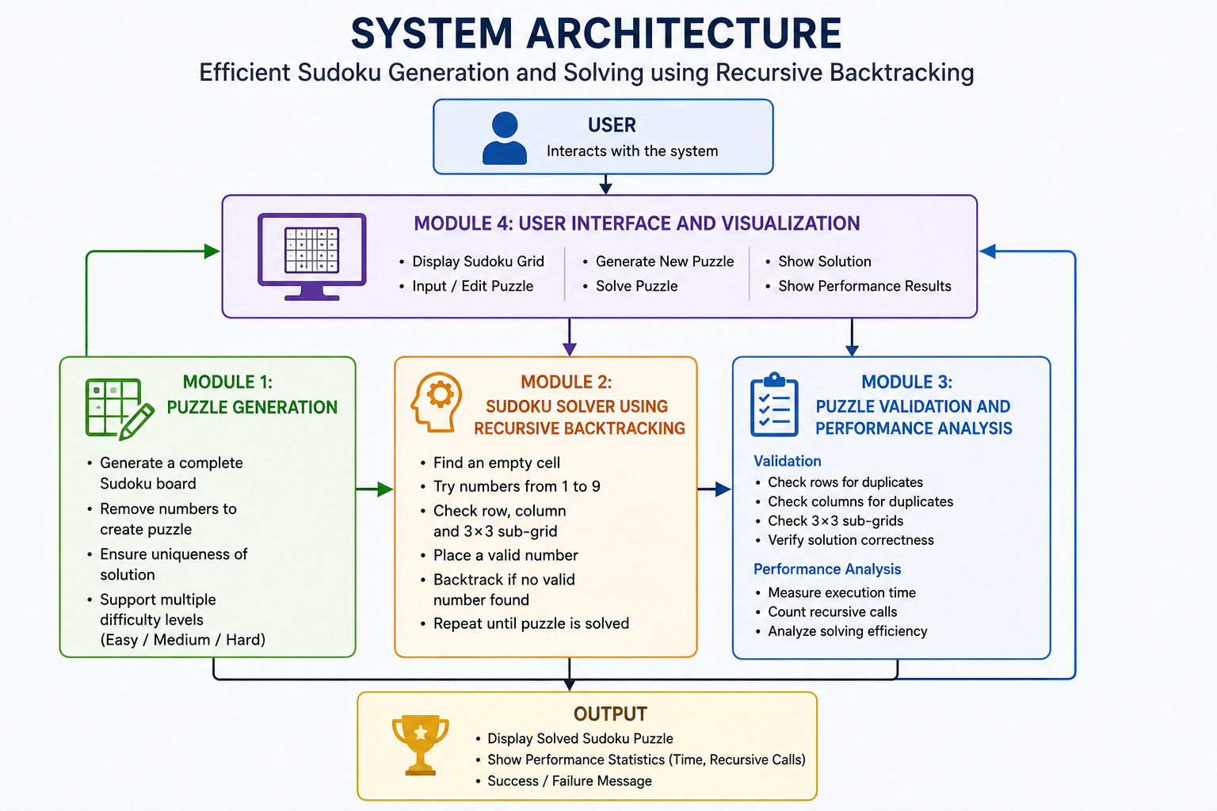
Appendix D – Performance Data Template
Difficulty | Execution time | Recursive calls | Result
Easy | Fill from actual run | Fill from actual run | Pass / Fail
Medium | Fill from actual run | Fill from actual run | Pass / Fail
Hard | Fill from actual run | Fill from actual run | Pass / Fail

Note: Exact numerical values must be copied from the executed application. They are intentionally not estimated in this report.
Appendix E – Individual Contribution Evidence
- Tkinter interface development and layout work.
- GUI control testing.
- Integration checks between interface events and Sudoku functions.
- Presentation preparation.
- Report preparation related to interface design and individual reflection.
Appendix F – Capstone Outcome Mapping
Outcome area | Evidence in report
Complex problem formulation | Chapter 1
Engineering design under constraints | Chapter 3
Technical communication | Complete report and presentation
Ethics and responsibility | Chapter 3
Teamwork | Chapter 4 and contribution statement
Experimentation and analysis | Chapter 4
Independent learning | Chapter 5
Standards and quality considerations | Chapter 3

